Notes for 1/24/2020 WRAP RH EI & modeling protocol subcommittee meeting

Agenda Items

Welcome, Roll Call, Notetaking (UT DAQ AZDEQ), and Agenda Review - Farren

Mobile Source EI 2014 to 2028 projections summary data and emissions changes by state and mobile sector – John
- Project wikipage: https://views.cira.colostate.edu/wiki/wiki/11203/mobile-source-emissions-inventory-projections-project, includes:
  - Project meeting recordings and summary presentations
  - Memo and 1/21 meeting recording coming soon
- Presentation of changes between 2016 to 2028 WRAP regional mobile source emissions
- NOx reductions across the board with the exception of large (38%) increases in airport emissions due to increased activity with no new federal standards.
- Substantial NOx decreases in onroad and nonroad vehicle emissions (-61% and -46% respectively).
- Drastic decreases in VOC sector emissions, except for marine and airports.
- State-specific NOx and VOC emission reductions between 2014 and 2028 are drastic.
- On the books regulations are decreasing 2-stroke and 4-stroke engine emissions for Nonroad sectors.
- Update needed to later slides that show ND reported twice instead of separate entries for NV and ND (NV omitted).
- CA emissions calculated separately and not reported here but will be integrated into modeling.
- Colorado concerned with current growth rate and if that rate may continue into the future and how it may impact these values. Ramboll relayed that population increases are accounted for in the model projections but Tier 3 emissions changes tend to dramatically overcome these increases and result in significant emission reductions.

Generally the changes to source categories “2014 to baseline” by state, including showing the grid cell state definitions, also EGU unit level “2014v2 to baseline” emissions changes in the WRAP region specifically – Tejas
- Presentation of changes in puts between the different modeling scenarios and the differences in emissions between the 2014v2 scenario and the representative baseline (RepBase) scenario
- Incorporated State inputs into the modeling, WRAP efforts, and filled remaining information with EPA modeling platform datasets. See table below.
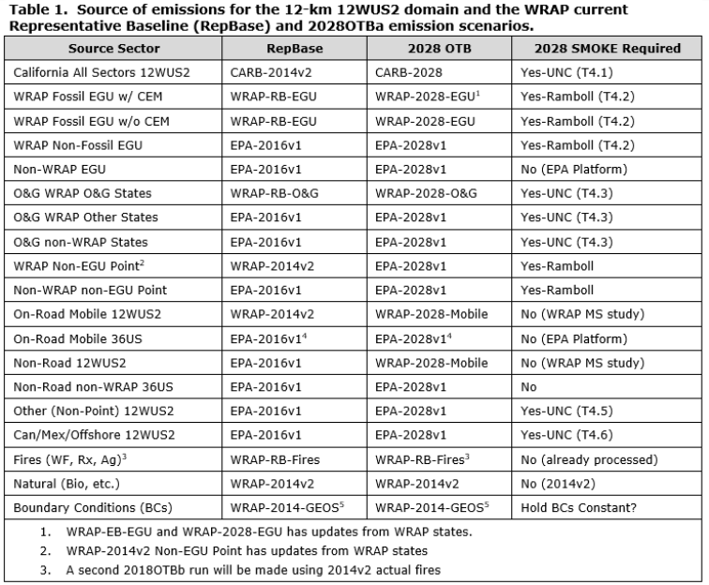
- WRAP EGU analysis relied on Clean Air Markets division data to determine historical and project future EGU emissions.
- Source sector aggregation was to 35 sectors in 2014 modeling and 40 sectors for the representative baseline modeling. CA stands alone.
- BEIS emissions were utilized and not MEGAN for biogenic emissions.
- For fire emissions, there were drastic increases in southeastern US fire emissions between 2014 and RepBase scenario and a variety of changes in the west with some areas increasing and some decreasing.
- EGU NOx and SO2 emissions drastically decrease between 2014v2 and RepBase for most States, with all States showing decreases between the two scenarios (except NOx in Washington, virtually unchanged).
- Total NOx anthropogenic emissions between 2014v2 and RepBase emissions are comparable for individual States; however, there are some slight increases in ND and WA, with all other States decreasing or staying steady.
- Dust emission decreases between 2014v2 and RepBase are primarily due to fugitive dust changes between the 2014 NEI and EPA 2016 fugitive dust emission reductions.
- NOx and SO2 offshore emissions are decreasing between 2014v2 and RepBase, again based on changes in EPA’s inventories.
- Why are their slight changes in the point O&G numbers between the two scenarios for certain States? Possibly due to OGWG method changes or a State specific change in the dataset.

Q&A on state inputs to "Potential Additional Controls” (PAC) modeling scenario – David Stroh and Farren
- Word document created for questions regarding the potential additional controls modeling. Farren and David gave feedback on New Mexico questions, such as:
  - What data needs to be submitted?
  - How is the data used?
  - Format for submitting information?
- Basically the same process for submittal of data for the previous modeling scenarios.
- States inputs are requested no later than March 16th for this “best-guess” control modeling.
- New Mexico is digesting the information in the document.

Progress on state inputs to PAC scenario, timing, other issues – Farren
- Next call States are requested to give updates on control evaluation (e.g. number of sources, size of sources, and potential emission reductions).

Next call date and time – Farren and all

